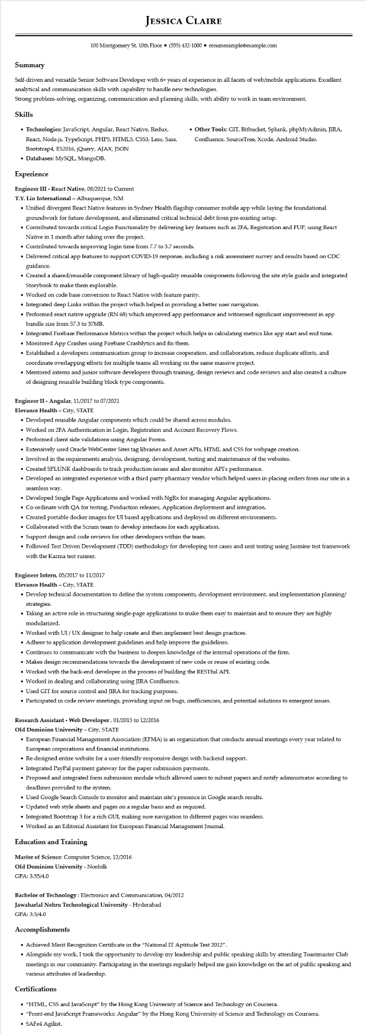
JESSICA CLAIRE
100 Montgomery St. 10th Floor⚫ (555) 432-1000⚫ resumesample@example.com
Summary
Self-driven and versatile Senior Software Developer with 6+ years of experience in all facets of web/mobile applications. Excellent analytical and communication skills with capability to handle new technologies.
Strong problem-solving, organizing, communication and planning skills, with ability to work in team environment.
Skills
• Technologies: JavaScript, Angular, React Native, Redux,
React, Node.js, TypeScript, PHP5, HTML5, CSS3, Less, Sass,
Bootstrap4, ES2016, jQuery, AJAX, JSON
• Databases: MySQL, MongoDB.
Experience
Engineer III - React Native, 08/2021 to Current
T.Y. Lin International - Albuquerque, NM
• Other Tools: GIT, Bitbucket, Splunk, phpMyAdmin, JIRA, Confluence, SourceTree, Xcode, Android Studio.
• Unified divergent React Native features in Sydney Health flagship consumer mobile app while laying the foundational groundwork for future development, and eliminated critical technical debt from pre-existing setup.
• Contributed towards critical Login Functionality by delivering key features such as 2FA, Registration and FUP, using React Native in 1 month after taking over the project.
• Contributed towards improving login time from 7.7 to 3.7 seconds.
• Delivered critical app features to support COVID-19 response, including a risk assessment survey and results based on CDC guidance.
• Created a shared/reusable component library of high-quality reusable components following the site style guide and integrated Storybook to make them explorable.
• Worked on code base conversion to React Native with feature parity.
• Integrated deep Links within the project which helped in providing a better user navigation.
• Performed react native upgrade (RN 68) which improved app performance and witnessed significant improvement in app bundle size from 57.3 to 37MB.
• Integrated Firebase Performance Metrics within the project which helps in calculating metrics like app start and end time. • Monitored App Crashes using Firebase Crashlytics and fix them.
• Established a developers communication group to increase cooperation, and collaboration, reduce duplicate efforts, and coordinate overlapping efforts for multiple teams all working on the same massive project.
• Mentored interns and junior software developers through training, design reviews and code reviews and also created a culture of designing reusable building block type components.
Engineer II - Angular, 11/2017 to 07/2021
Elevance Health - City, STATE
• Developed reusable Angular components which could be shared across modules.
• Worked on 2FA Authentication in Login, Registration and Account Recovery Flows.
• Performed client side validations using Angular Forms.
• Extensively used Oracle WebCenter Sites tag libraries and Asset APIs, HTML and CSS for webpage creation.
• Involved in the requirements analysis, designing, development, testing and maintenance of the websites.
• Created SPLUNK dashboards to track production issues and also monitor API's performance.
• Developed an integrated experience with a third party pharmacy vendor which helped users in placing orders from our site in a seamless way.
• Developed Single Page Applications and worked with NgRx for managing Angular applications.
• Co-ordinate with QA for testing, Production releases, Application deployment and integration.
• Created portable docker images for UI based applications and deployed on different environments.
• Collaborated with the Scrum team to develop interfaces for each application.
• Support design and code reviews for other developers within the team.
• Followed Test Driven Development (TDD) methodology for developing test cases and unit testing using Jasmine test framework with the Karma test runner.
Engineer Intern, 05/2017 to 11/2017
Elevance Health - City, STATE
• Develop technical documentation to define the system components, development environment, and implementation planning/ strategies.
• Taking an active role in structuring single-page applications to make them easy to maintain and to ensure they are highly modularized.
• Worked with UI/UX designer to help create and then implement best design practices.
• Adhere to application development guidelines and help improve the guidelines.
• Continues to communicate with the business to deepen knowledge of the internal operations of the firm.
• Makes design recommendations towards the development of new code or reuse of existing code.
• Worked with the back-end developer in the process of building the RESTful API.
• Worked in dealing and collaborating using JIRA Confluence.
• Used GIT for source control and JIRA for tracking purposes.
• Participated in code review meetings, providing input on bugs, inefficiencies, and potential solutions to emergent issues.
Research Assistant - Web Developer, 01/2015 to 12/2016
Old Dominion University - City, STATE
• European Financial Management Association (EFMA) is an organization that conducts annual meetings every year related to European corporations and financial institutions.
• Re-designed entire website for a user-friendly responsive design with backend support.
• Integrated PayPal payment gateway for the paper submission payments.
•
Proposed and integrated form submission module which allowed users to submit papers and notify administrator according to deadlines provided to the system.
• Used Google Search Console to monitor and maintain site's presence in Google search results.
• Updated web style sheets and pages on a regular basis and as required.
• Integrated Bootstrap 3 for a rich GUI, making sure navigation to different pages was seamless.
• Worked as an Editorial Assistant for European Financial Management Journal.
Education and Training
Master of Science: Computer Science, 12/2016
Old Dominion University - Norfolk
GPA: 3.55/4.0
Bachelor of Technology: Electronics and Communication, 04/2012
Jawaharlal Nehru Technological University - Hyderabad
GPA: 3.5/4.0
Accomplishments
• Achieved Merit Recognition Certificate in the "National IT Aptitude Test 2012".
• Alongside my work, I took the opportunity to develop my leadership and public speaking skills by attending Toastmaster Club meetings in our community. Participating in the meetings regularly helped me gain knowledge on the art of public speaking and various attributes of leadership.
Certifications
• "HTML, CSS and JavaScript" by the Hong Kong University of Science and Technology on Coursera.
• "Front-end JavaScript Frameworks: Angular" by the Hong Kong University of Science and Technology on Coursera.
• SAFe4 Agilist.

